Chapter 5, Solution 92

Refer to the bridge amplifier shown in Fig. 5.109. Determine the voltage gain v_{o}/v_{i} .

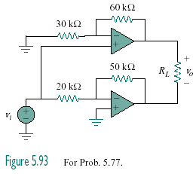
Figure 5.109
For Prob. 5.92.

Solution

The top op amp circuit is a non-inverter, while the lower one is an inverter. The output at the top op amp is

v₁ = (1 + 60/30)v_{i} = 3v_{i}

while the output of the lower op amp is

v₂ = -(50/20)v_{i} = -2.5v_{i}

Hence, v_{o} = v₁ – v₂ = 3v_{i} + 2.5v_{i} = 5.5v_{i}

v_{o}/v_{i} = 5.5

